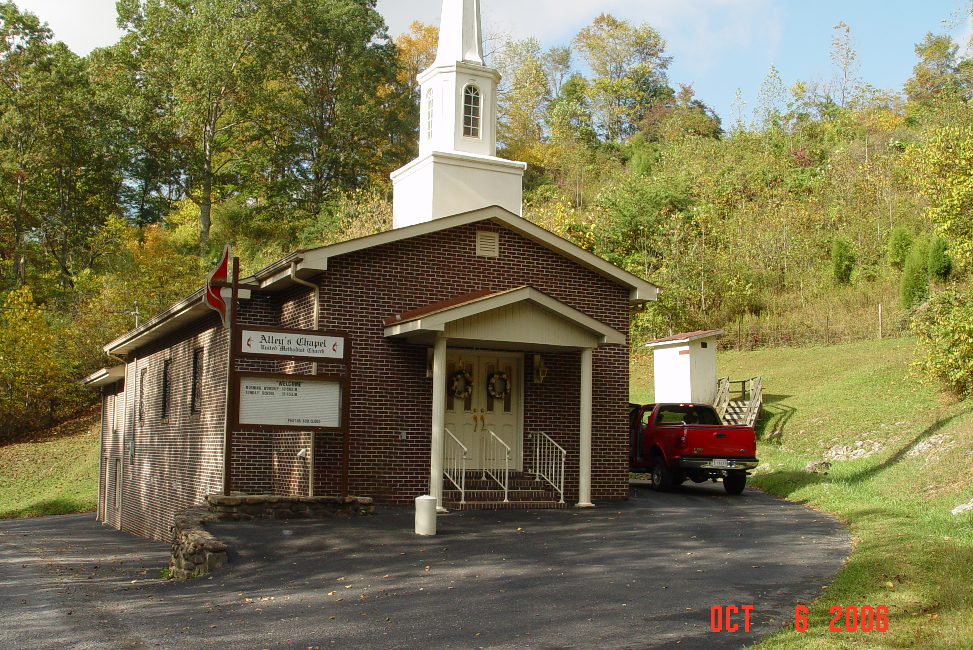

Alleys Chapel Deed
Bob McConnells Great-great-grandparents and Blaine's Great-grand parents

This deed made this 19th day of June, 1884 between David J. Alley and Mary his wife of the county of Scott and state of Virginia of the first part and James M. Newton of the county and state aforesaid of the second part witnesseth. The said David J. Alley and Mary his wife are willing and desires to promote the causes of true piety religion and to aid in securing and building a church for the worship of Almighty God: and whereas there are private reasons moving the said to Alley and wife decline conveying land to any trustees for the purpose of building a denominational Church on, nevertheless being anxious to secure a church in their neighborhood whether they the said parties of the first part are entirely willing that the said James M. Newton shall determine what denomination of Orthodox Christians shall build own and control said Church house and to deed and convey the land herein after described to such trustees we may have been chosen or may hereafter be chosen for the purpose of building a church house on: now for and in consideration of one dollar in hand paid by said Newton to the parties of the first part at and before the unsealing and delivery of these presents, the receipt of which is hereby acknowledged, the said parties have granted bargained and sold and by these presents to grant bargain and sell unto the said James M. Newton and his assigns a certain lot or parcel of land lying and being in said county on The Black Oak Branch in Templeton Valley in said county adjoining the lands of said Alley and S.M. Templeton and is bounded as follows, to wit: Beginning at the said land on a stone close by a hornbeam maple and sourwood, thence running a few degrees north of west 82/3 poles to a stone , then a few degrees west of south 5 poles to a stone thence some degrees south of east 8 poles to a stone thence east 3 poles to the branch, thence with the meanders of said branch North to the beginning corner containing about one half of an of an acre more or less. To have and to hold said land unto the said Newton and his assigns forever for the purpose above herein recited. It is hereby expressly declared to be the intention of the said David J. Alley and Mary his wife to convey, give and release said above described land for the purpose of building a church house. Thereon to be used forever for the worship of Almighty God and whenever any or all denominations of Orthodox Christians shall cease to use the same as a house of worship as above recited for the period of five years. Then said land shall revert for the period of five years. Then said land shall revert to said Alley and his heirs.
Witness The following signatures and seals the day and date first above written.

David Alley seal
Mary Allley seal

Virginia Scott County to wit:
I John M. Johnson, clerk of the county court in the State aforesaid do certify that David Alley whose name is signed to the foregoing writing bearing date on the 19th day of June, 1884 has acknowledged the same before me in my county aforesaid. And I further certify that Mary J. Alley, the wife of the said David J. Alley whose name is likewise signed to the writing above bearing date on the 19th “day” of June. 1884, personally appeared before me in my county aforesaid and being examined by me apart from her husband, and having the writing aforesaid fully explained.

John M. Johnson, Clerk

Sandra Pendleton is the 2nd Grand Niece of Wm. S. Lane

Raymond Lee Pendleton is the @ 2nd Grand Nephew of John Emerson Pendleton
This was my (Kens) Great Grandad he fought in the Civil War, was minister of Alleys and passed away in 1923.

This deed made this 20th day of August, 1884, between James M. Newton and E.H. Newton his wife of the county of Scott and state of Virginia of the first part and Wm. S. Lane, Amos M. Templeton, Robert Penley, John E. Pendleton and James O. Lane trustees in and for the Methodist Episcopal Church in the United States of America and their successors of the second part witness that in hereas the said James M. Newton & Elizabeth H. his wife being desirous to promote the cause of Christianity & true fiery and to secure a place for to build a church house on for the worship of Almighty God, has this day bargained sold & conveyed unto the above named trustees or their successors in and for the Methodist Episcopal Church of the United States of America a certain tract or parcel of land. Now for and in consideration of one dollar to me in hand paid the receipt of which is hereby acknowledged do bargain sell and convey unto the Methodist Episcopal Church of America and in trust that said premises shall be used, kept maintained & disposed of as a place of Divine worship for the use of the ministry and membership of the Methodist Episcopal Church in the United States of America. Subject to the Discipline usage and Ministerial appointments of said church as from time to time authorized and declared by the General Conference of said church and the Annual Conference within whose bounds the said premises are situated. Now the said J.M. Newton & Elizabeth H. his wife of the first part, do by these presence grant bargain sell and convey the following tract or pared of land lying and being in said on the blackoak branch in Templeton Valley in said county adjoining the lands of David J. Alley & Amous M. Templeton and bounded as follows to wit: Beginning at the said branch on a stone close by a hornbeam, Maple & Sourwood Thence running a few degrees north of ebest 8 2/3 poles to a stone thence a few degrees west of south 5 poles to a stone thence some degrees south of east 8 poles to a stone thence east 3 poles to the branch thence with the meanderin of said branch north to the beginning corner containing about one half of an acre, more or less to have and to hold for the above named purpose forever. Now whenever this property ceases to be used for the above named purpose for the term of five years then it is to REVERT to the said James M. Newton his heirs or assigners Witness the following signatures and seals this day and date first above written.

James M. Newton Seal
Elizabeth H. Newton Seal

Virginia Scott County Court Clerk’s Office
I John M. Johnson clerk of said county do certify that James M. Newton whose name is signed to the forgoing writing bearing date on the 20th day of August, 1884, has acknowledged the same before me in my county aforesaid. And I further certify that Elizabeth Newton the wife of the said James M. Newton whose name is likewise signed to the writing bearing date as aforesaid personally appeared before me and being examined by me firmly and apart from her said husband and having the writing afore said fully explained to her she the said, Elizabeth Newton acknowledged the same and declared that she had willingly exiled the same and that she wished not to retract it .
Given under my hand this 21st day of August, 1884.

J.M. Johnson, Clerk

DB22/P-225
This Indenture made the Second Day of February in the year of our lord on Thousand Eight Hundred and Eighty Five, between the trustees of the Methodist Episcopal Church of Alleys Chapel, in the county of Scott, and state of Virginia connected with the Virginia Annual Conference of the Methodist Episcopal Church, party of the first part and Board of Church extension of the Methodist Episcopal Church incorporated by the Legislature of the state of Pennsylvania, party of the second part, whereas, the party of the first part has applied to the said party of the second part for aid to enable said church to procure and possess a House of Worship, adaptive to the wants thereof, and to be by said church held in trust as provided in the Discipline of the Methodist Episcopal Church; and whereas the said party of the second part has granted such aid to the amount of Two Hundred Dollars $200.00. Now, therefore, this indenture witnessed, that the said party of the first part , in consideration of the above amount, does for itself and its successors, hereby covenant, grant, promise and agree to and with the said Party of the second part, and does, hereby become bound unto said party as follows: That in case the said party of the first party shall cease to be connected with the Methodist Episcopal Church, or the corporate existence of the said party of the first party shall cease, or the House of Worship be alienated, then, and in such case, the party of the first part, shall and will forth with refund to the said party of the second part, the successions or assigns thereof, the said amount with interest thereon from the time of reserving it. This indenture further witnesseth that the said party of the first part for the better securing the performance by in of the covenant and obligation above mentioned and the repayment of the said amount, with interest thereon from the time of requiring it, to the said party of the second party, in the case above mentioned, and in consideration of one Dollar ($1.00) to said first party, paid by said party of the second part, the receipt of which is hereby acknowledged, as granted, sold conveyed, and confirmed, and by these presents doth grant, sell, convey and confirm unto the party of the second part, and to its successors and assigns forever. All the following described Real Estate lying and being situated in the county of Scott and state of Virginia: to wit: a certain tract, lot on parcel of land in said county on the Black Oak Branch in Templeton Valley adjoining the land of David J. Alley and Amos M. Templeton and others and bounded as follows to wit: Beginning at the said branch on a stone close by a hornbeam , Maple and Sourwood, thence running a few degrees north of west 8 2/3 poles to a stone thence a few degrees west of south 5 poles to a stone thence some degrees south by east 8 poles to a stone, thence east 3 poles to the branch, thence with the meanders of said branch north to the beginning together with all and singular the tenements, hereditaments and oppertaining, and the reversion as well in law as in equity of the partyof the party of the first part of in and to the same, and every part thereof, with the opportunities to have and to hold the above granted and described premises with the opportunities unto the party of the second part, its successors and assigns, to its own proper use benefit and behoof , forever. Provided always and these presents are upon this express condition that the party of the first part , its successors or assigns, shall well and truly keep, perform and fulfill the covenant and obligations herin above contained and shall, in the case herein above, well and truly refund unto the said party of the second part the said amount wiith interest thereon from the time of receiving it, then these presents and the estate hereby granted shall cease, determine and be void. And the party of the first part, for itself its successors and assigns, doth covenant and agree to and with the said party of the second part, that in case the said party of the first part, or its successors, shall cease to be connected with the Methodist Episcopal Church, or the corporate existence of the said party of the first part shall cease, on the house of worship be alimented, that then it shall be lawful for the party of the second part, its successors or assigns, to enter into land before all and singular the premises hereby granted, or intended so to be, and to sell and dispose of the same and all benefits and equity of redemption of the party of the first part, its successors or assigns therein, at public auction, according to the act in such cases made and provided. And as the attorney of the partyof the first part for that purpose by these presents duly authorized constituted and appointed to make and deliver to the purchases or purchaser thereof a good and sufficient deed or deeds of conveyance in the law for the same, in for simple and out of the money arising from such sale to retain the said amount herein first above mentioned, and interest thereon as herein above provided, together with the costs and charges of advertisement and sale of the said premises, rendering the overflow of the purchase money, (if any there shall be) unto the party of the first part, its successors or assigns, which sale so to be made shall forever be a perpetual bar, both in law and equity against the party of the first part, its successors and assigns and all other persons claiming or to claim the premises, or any part thereof, by, through, or under it. And the said party of the first further agrees to keep the buildings insured in and by some incorporated company in good standing against loss or damage by fire in at least the sum of Five Hundred Dollars ($500), and will at any time, when required so to do, assign the policy of such insurance to said party of the second part.
In witness whereof the said party has by the undersigned lawfully constituted trustees being thereto authorize according to law executive this indenture, on the day and year first herein above written.

Witness William S. Lane
M.B. Wood Robert Penley
J.F. Templeton Trustees: James B. Lane
Amos M. Templeton
John E. Pendleton

State of Virginia -- County of Scott
On this second day of February, A.D. 1885 before me Clerk of the County Court in and for said County and state personally came the above named Wm. S. Lane, Robert Penley, James O. Lane, Amos M. Pendleton and John E. Pendleton know to me to be the persons whose names are subscribed and trustees as reoiled in the foregoing indenture and as such duly authorized according to law to execute the same for the purposes therein mentioned as the voluntary act and deed of the aforesaid Alleys Chappel Methodist Episcopal Church of Templeton Valley in Scott County, Virginia
J.M. Johnson, Clerk

Virginia Scott County Court Clerks Office
This indenture from the Trustees of the Methodist Episcopal Church to the Board of Church Extutions of Methodist Episcopal Church bearing date 2 day of February 1883 was received and together with the certificate hereon advicted to my lord.
Given under my Lord on this 6th day of March 1885
J.M. Johnson, Clerk

Summary Page

Alleys Chapel Deed

1. This deed made this 19th day of June, 1884 between David J. Alley and Mary his wife of the county of Scott and state of Virginia of the first part and James M. Newton of the county and state aforesaid of the second part witnesseth.

2. Alley and wife to decline conveying land to any trustees for the purpose of building a denominational Church on, nevertheless being anxious to secure a church in their neighborhood whether they the said parties of the first part are entirely willing that the said James M. Newton shall determine what denomination of Orthodox Christians shall build own and control said Church house and to deed and convey the land herein after described to such trustees we may have been chosen or may hereafter be chosen for the purpose of building a church house on: now for and in consideration of one dollar in hand paid by said Newton to the parties of the first part

3. This deed made this 20th day of August, 1884, between James M. Newton and E.H. Newton his wife of the county of Scott and state of Virginia of the first part and Wm. S. Lane, Amous M. Templeton, Robert Penley, John E. Pendleton and James O. Lane trustees in and for the Methodist Episcopal Church in the United States of America and their successors of the second part witness that in hereas the said James M. Newton & Elizabeth H. his wife being desirous to promote the cause of Christianity & true fiery and to secure a place for to build a church house on for the worship of Almighty God, has this day bargained sold & conveyed unto the above named trustees or their successors in and for the Methodist Episcopal Church of the United States of America a certain tract or parcel of land. Now for and in consideration of one dollar to me in hand paid the receipt of which is hereby acknowledged do bargain sell and convey unto the Methodist Episcopal Church of America and in trust that said premises shall be used, kept maintained & disposed of as a place of Divine worship for the use of the ministry and membership of the Methodist Episcopal Church in the United States of America. Subject to the Discipline usage and Ministerial appointments of said church as from time to time authorized and declared by the General Conference of said church and the Annual Conference within whose bounds the said premises are situated. Now the said J.M. Newton & Elizabeth H. his wife of the first part, do by these presence grant bargain sell and convey the following tract or pared of land lying and being in said on the blackoak branch in Templeton Valley

4.This Indenture made the Second Day of February in the year of our lord on Thousand Eight Hundred and Eighty Five, between the trustees of the Methodist Episcopal Church of Alleys Chapel, in the county of Scott, and state of Virginia connected with the Virginia Annual Conference of the Methodist Episcopal Church, party of the first part and Board of Church extension of the Methodist Episcopal Church incorporated by the Legislature of the state of Pennsylvania,

5. the party of the first part has applied to the said party of the second part for aid to enable said church to procure and possess a House of Worship, adaptive to the wants thereof, and to be by said church held in trust as provided in the Discipline of the Methodist Episcopal Church; and whereas the said party of the second part has granted such aid to the amount of Two Hundred Dollars $200.00.

